**Polymorphism:**

**Design a class hierarchy for a simple graphic editor with base class Shape and derived classes Circle, Rectangle, and Triangle. Implement a virtual function draw() in the base class and override it in the derived classes. Write a function that takes a Shape* and calls its draw() method.**

#include <iostream>

using namespace std;

class Shape {

public:

virtual ~Shape() {}

virtual void draw() = 0;

};

class Circle : public Shape {

public:

void draw() override {

cout << "Draw Circle" << endl;

}

};

class Rectangle : public Shape {

public:

void draw() override {

cout << "Draw Rectangle" << endl;

}

};

class Triangle : public Shape {

public:

void draw() override {

cout << "Draw Triangle" << endl;

}

};

void displayShape(Shape* shape) {

shape->draw();

}

int main() {

Circle circle;

Rectangle rectangle;

Triangle triangle;

displayShape(&circle);

displayShape(&rectangle);

displayShape(&triangle);

return 0;

}

**Output:**

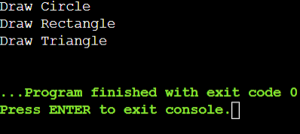

**Static Members:**

**Create a class Account that has a static data member totalAccounts to keep track of the number of accounts created. Implement necessary constructors and destructors to update totalAccounts. Write a function to display the total number of accounts.**

#include <iostream>

using namespace std;

class Account {

private:

static int totalAccounts;

public:

// Constructor

Account() {

totalAccounts++;

}

// Destructor

~Account() {

totalAccounts--;

}

static int getTotalAccounts() {

return totalAccounts;

}

};

int Account::totalAccounts = 0;

void displayTotalAccounts() {

cout << "Total Accounts: " << Account::getTotalAccounts() << endl;

}

int main() {

Account acc1;

Account acc2;

Account acc3;

displayTotalAccounts();

{

Account acc4;

displayTotalAccounts();

}

displayTotalAccounts();

return 0;

}

**Output:**

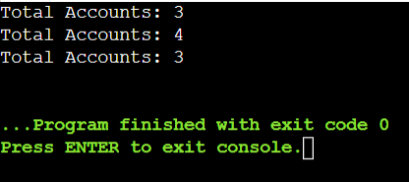

**Friend Functions:**

**Implement a class Box that has private data members length, breadth, and height. Write a friend function volume() that calculates and returns the volume of the box. Create objects of Box and use the friend function to compute their volumes.**

#include <iostream>

using namespace std;

class Box {

private:

float length, breadth, height;

public:

Box(float l, float b, float h) : length(l), breadth(b), height(h) {}

friend float volume(const Box& box) {

return box.length * box.breadth * box.height;

}

};

int main() {

Box box1(2.5f, 3.5f, 4.5f);

cout << "Volume of box1: " << volume(box1) << endl;

Box box2(1.5f, 2.5f, 3.5f);

cout << "Volume of box2: " << volume(box2) << endl;

return 0;

}

**Output:**

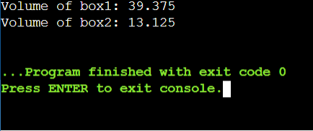

**Templates:**

**Write a template class Array that can store an array of any data type. Include member functions to perform operations like adding an element, removing an element, and displaying the array. Demonstrate the functionality with different data types.**

#include <iostream>

using namespace std;

template <typename T, int Capacity>

class Array {

private:

T elements[Capacity];

int size;

public:

Array() : size(0) {}

void addElement(const T& element) {

if (size < Capacity) {

elements[size++] = element;

} else {

cout << "Array is full. Cannot add more elements." << endl;

}

}

void removeElement(int index) {

if (index < 0 || index >= size) {

cout << "Invalid index. Cannot remove element." << endl;

} else {

elements[index] = elements[size - 1];

size--;

}

}

void displayArray() const {

if (size == 0) {

cout << "Array is empty." << endl;

} else {

cout << "Array elements: ";

for (int i = 0; i < size; ++i) {

cout << elements[i] << " ";

}

cout << endl;

}

}

};

int main() {

Array<int, 5> intArray;

intArray.addElement(35);

intArray.addElement(45);

intArray.addElement(55);

intArray.displayArray();

// Remove an element

intArray.removeElement(1);

intArray.displayArray();

Array<string, 2> stringArray;

stringArray.addElement("Kavya");

stringArray.addElement("Vamsi");

stringArray.displayArray();

// Remove an element

stringArray.removeElement(1);

stringArray.displayArray();

return 0;

}

**Output:**

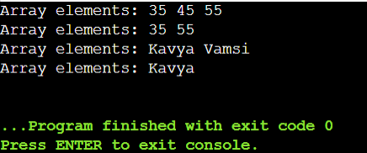

**Pointers:**

**Design a class Student with data members name and age. Create an array of Student objects dynamically using pointers. Implement functions to set and display the details of students. Also, write a function to deallocate the memory.**

#include <iostream>

#include <string>

using namespace std;

class Student {

private:

string name;

int age;

public:

Student( const string& studentName, int studentAge) : name(studentName), age(studentAge) {}

void displayDetails() const {

cout << "Name: " << name << ", Age: " << age << endl;

}

};

int main() {

const int numStudents = 4;

Student* studentArray[numStudents];

studentArray[0] = new Student("Kavya", 23);

studentArray[1] = new Student("Vamsi", 28);

studentArray[2] = new Student("Jahnavi",24);

studentArray[3] = new Student("Nani", 22);

for (int i = 0; i < numStudents; ++i) {

cout << "Student " << (i + 1) << ": ";

studentArray[i]->displayDetails();

}

for (int i = 0; i < numStudents; ++i) {

delete studentArray[i];

}

return 0;

}

**Output:**

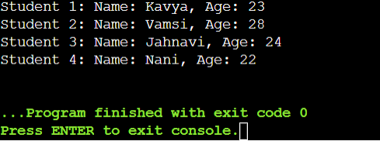

**Polymorphism with Abstract Classes:**

**Create an abstract class Animal with a pure virtual function sound(). Derive classes Dog, Cat, and Cow from Animal and override the sound() function in each derived class. Write a program to demonstrate polymorphism using these classes.**

#include <iostream>

using namespace std;

class Animal {

public:

virtual void sound() = 0;

};

class Dog : public Animal {

public:

void sound() override {

cout << " Woof!" << endl;

}

};

class Cat : public Animal {

public:

void sound() override {

cout << "Meow!" << endl;

}

};

class Cow : public Animal {

public:

void sound() override {

cout << "Moo!" << endl;

}

};

int main() {

int numAnimals = 3;

Animal* animals[numAnimals] = {

new Dog(),

new Cat(),

new Cow()

};

for (int i = 0; i < numAnimals; ++i) {

animals[i]->sound();

}

return 0;

}

**Output:**

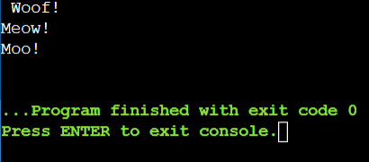

**7.Static Member Functions:**

**Implement a class Math that has static member functions for basic mathematical operations like addition, subtraction, multiplication, and division. Demonstrate the use of these functions without creating an object of the class.**

#include <iostream>

using namespace std;

class Math {

public:

static int addition(int a, int b) {

return a + b;

}

static int subtraction(int a, int b) {

return a - b;

}

static int multiplication(int a, int b) {

return a * b;

}

static double division(int a, int b) {

if (b == 0) {

cerr << "Error: Division by zero!" << endl;

return 0.0; // Error case

}

return static_cast<double>(a) / b;

}

};

int main() {

int x = 10, y = 11;

cout << "Addition: " << Math::addition(x, y) << endl;

cout << "Subtraction: " << Math::subtraction(x, y) << endl;

cout << "Multiplication: " << Math::multiplication(x, y) << endl;

cout << "Division: " << Math::division(x, y) << endl;

return 0;

}

**Output:**

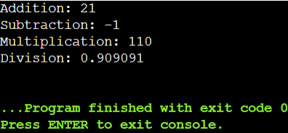

**8.Friend Classes:**

**Create two classes Alpha and Beta. Make Beta a friend class of Alpha so that it can access private data members of Alpha. Implement functions in Beta to manipulate the private data of Alpha.**

#include <iostream>

using namespace std;

class Beta;

class Alpha {

private:

int data;

public:

Alpha(int value) : data(value) {}

void display() const {

cout << "Alpha data: " << data << endl;

}

friend class Beta;

};

class Beta {

public:

void setData(Alpha& a, int value) {

a.data = value;

}

void addData(Alpha& a, int value) {

a.data += value;

}

};

int main() {

Alpha a(10);

a.display();

Beta b;

b.setData(a, 50);

cout << "After setting data to 50:" << endl;

a.display();

b.addData(a, 60);

cout << "After adding 6o to data:" << endl;

a.display();

return 0;

}

**Output:**

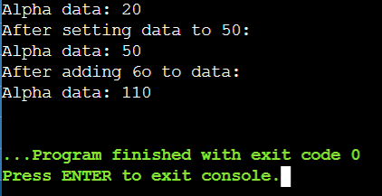

**9.Class Templates with Multiple Parameters:**

**Write a class template Pair that can store a pair of values of any two data types. Include member functions to set and get the values. Demonstrate the usage of this template with different data types.**

#include <iostream>

#include <string>

using namespace std;

template <typename T1, typename T2>

class Pair {

private:

T1 first;

T2 second;

public:

void setValues(const T1& f, const T2& s) {

first = f;

second = s;

}

T1 getFirst() const {

return first;

}

T2 getSecond() const {

return second;

}

void display() const {

cout << "First: " << first << ", Second: " << second << endl;

}

};

int main() {

Pair<int, double> p1;

p1.setValues(26, 7.14);

cout << "Pair1: " << endl;

p1.display();

Pair<string, int> p2;

p2.setValues("Age", 23);

cout << "\nPair2:" << endl;

p2.display();

return 0;

}

Output:

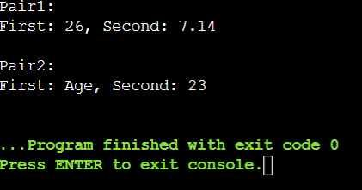

**10.Pointer to Objects:**

**Define a class Book with data members title and author. Create an array of pointers to Book objects. Write functions to input details for each book, display the details, and search for a book by title.**

#include <iostream>

#include <string>

using namespace std;

class Book {

private:

string title;

string author;

public:

void setDetails(const string& t, const string& a) {

title = t;

author = a; }

string getTitle() const {

return title; }

void display() const {

cout << "Title: " << title << ", Author: " << author << endl;

}

};

void inputDetails(Book* books[], int n) {

string title, author;

for (int i = 0; i < n; ++i) {

cout << "Enter details for book " << i + 1 << endl;

cout << "Title: ";

getline(cin, title);

cout << "Author: ";

getline(cin, author);

books[i] = new Book();

books[i]->setDetails(title, author);

}

}

void displayDetails(Book* books[], int n) { // Function to display details of all books

for (int i = 0; i < n; ++i) {

books[i]->display();

}

}

Book* searchByTitle(Book* books[], int n, const string& title) {

for (int i = 0; i < n; ++i) {

if (books[i]->getTitle() == title) {

return books[i];

}

}

return nullptr;

}

int main() {

int n;

cout << "Enter the number of books: ";

cin >> n;

cin.ignore();

Book* books[n];

inputDetails(books, n);

cout << "\nDisplaying book details:\n";

displayDetails(books, n);

string title;

cout << "\nEnter the title of the book to search: ";

getline(cin, title);

Book* foundBook = searchByTitle(books, n, title);

if (foundBook) {

cout << "\nBook found:\n";

foundBook->display();

} else {

cout << "\nBook not found.\n";

}

return 0;

}

**Output:**

